Fig. 2 - Data shape of our dataset

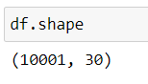

Fig. 3 - Data info of our dataset

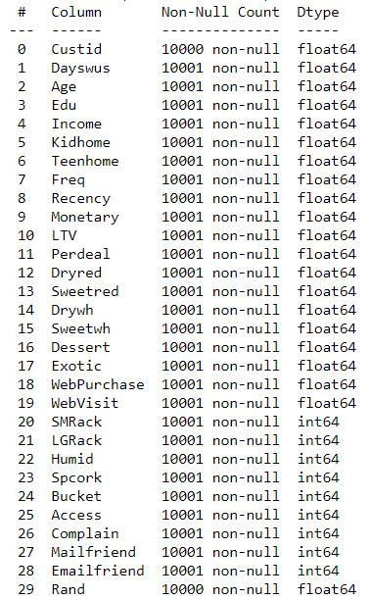

Fig 4 – Initial Histograms

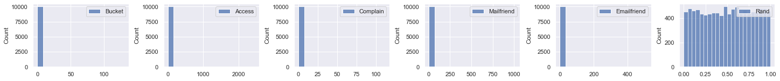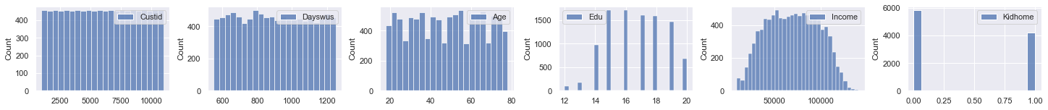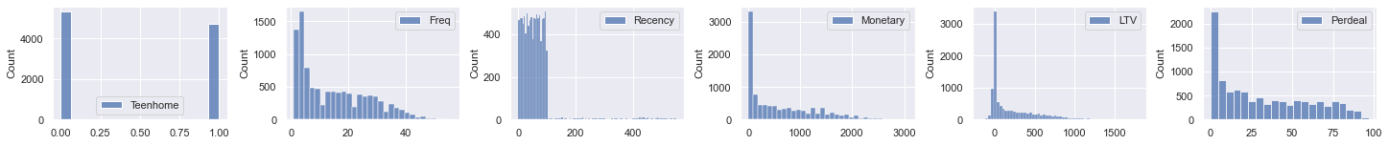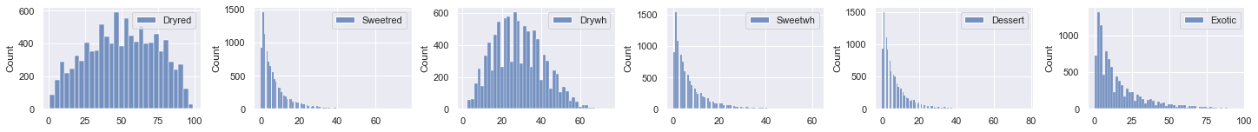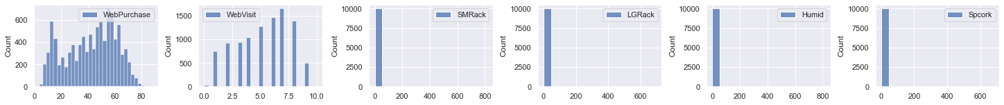

Fig 5 – Initial Boxplots

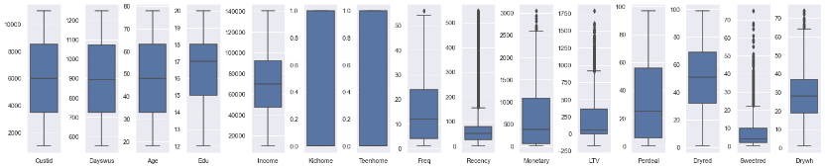

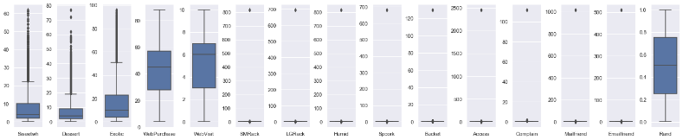

Fig 5 – Initial Pair Plot

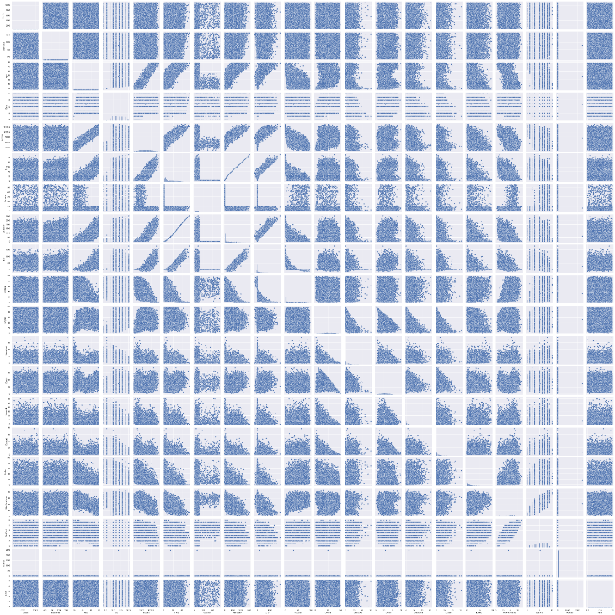

Fig 6 – Pearson Correlation

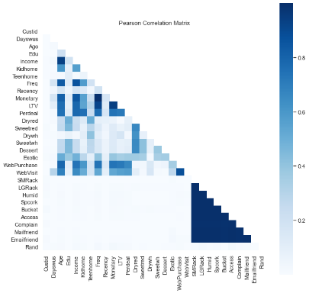

Fig 7 – Phik Correlation

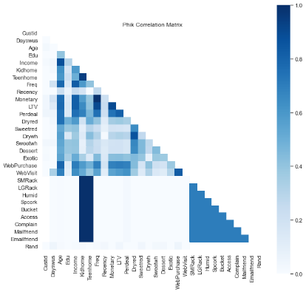

Fig 8 – Spearman Correlation

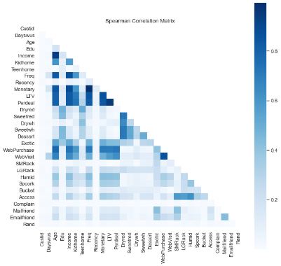

Fig 9 – Outliers PCA Visualization

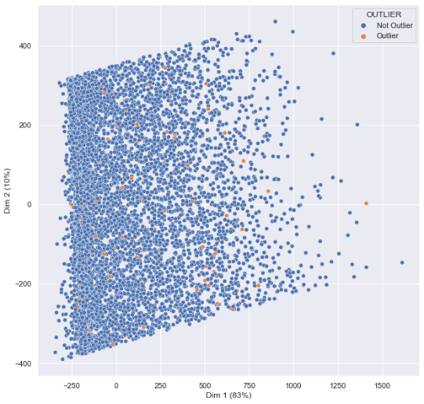

Fig. 10 – Feature Importance with Random Forest

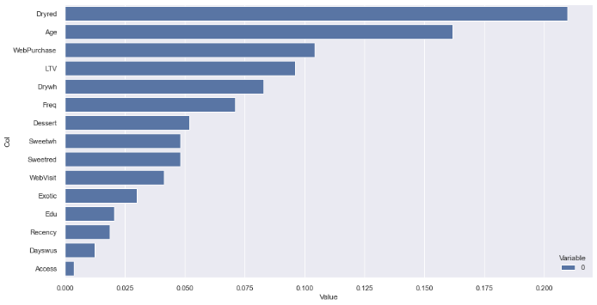

Fig. 11 – R2 Calculation for each Model

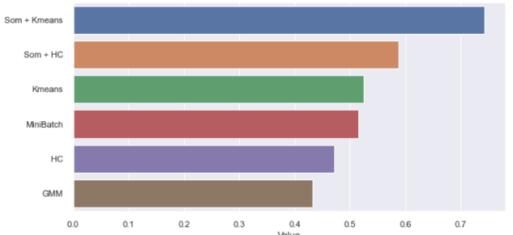

Fig. 12 – Multicorrespondence Analysis of Categorical Features

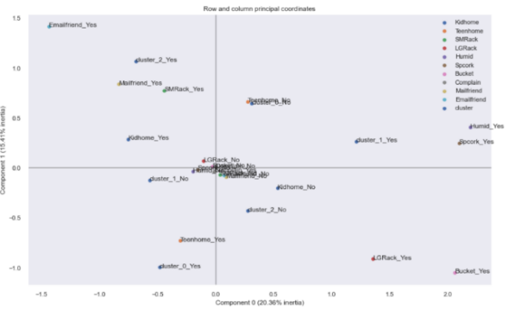

Fig. 13 – Cluster Simple Profiling (SOM + K-means)

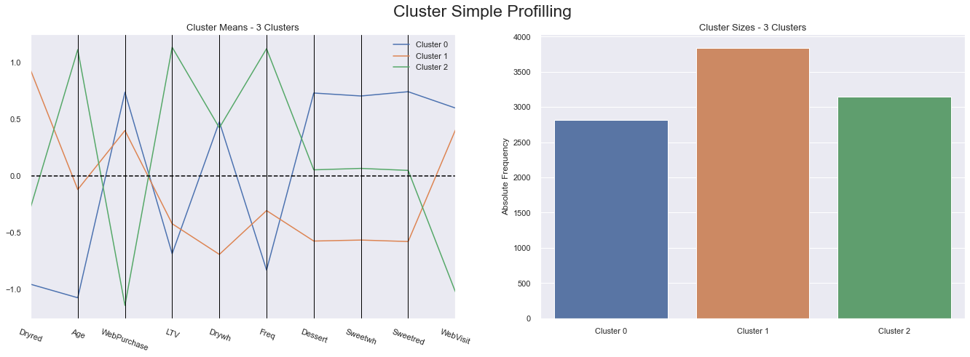

**Additional Visualizations:**

Boxplot of metric features after feature engineering

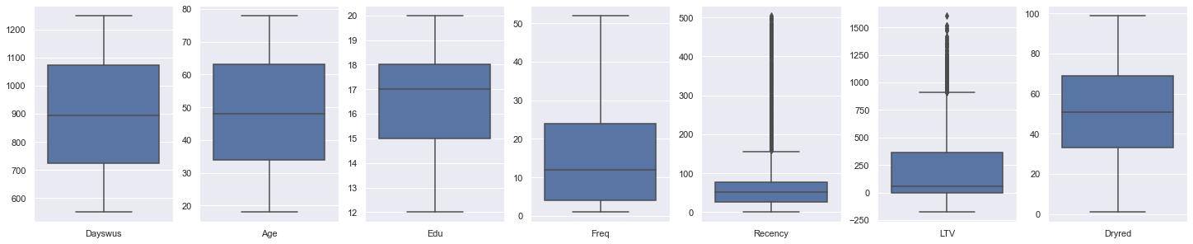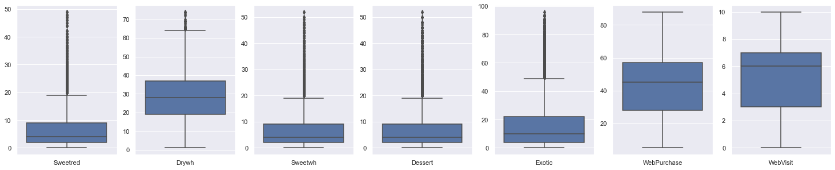

Histograms of metric features after feature engineering

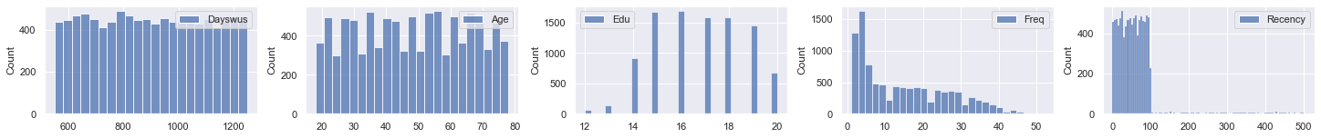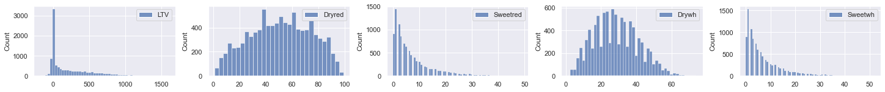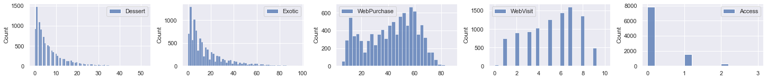

Histograms of non-metric features after feature engineering

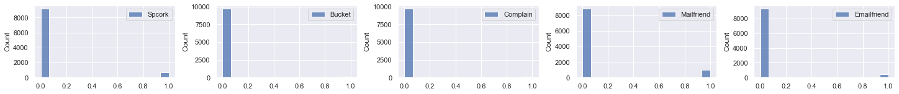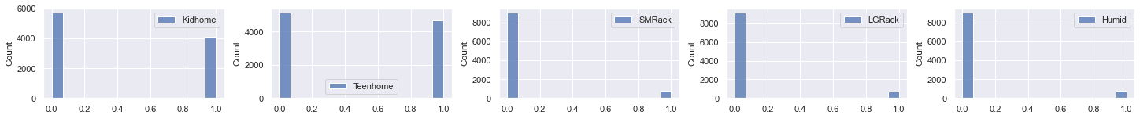

Violin Plot for metric features after feature engineering

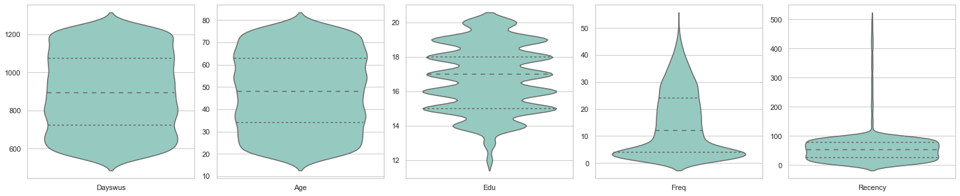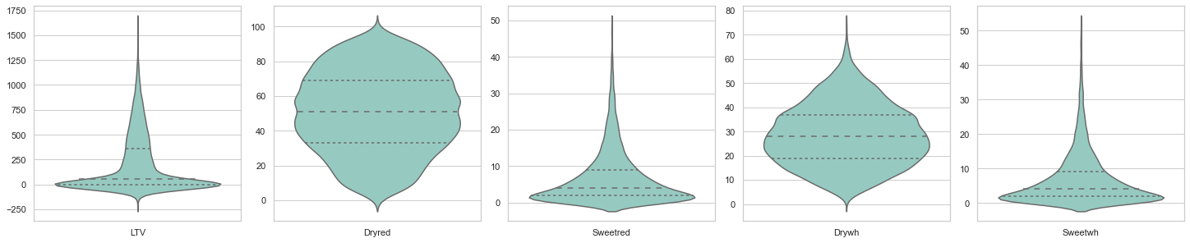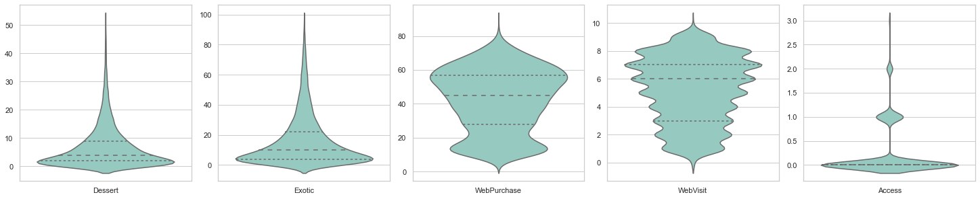

SOM + K-Means Calinski-Harabasz Elbow Plot

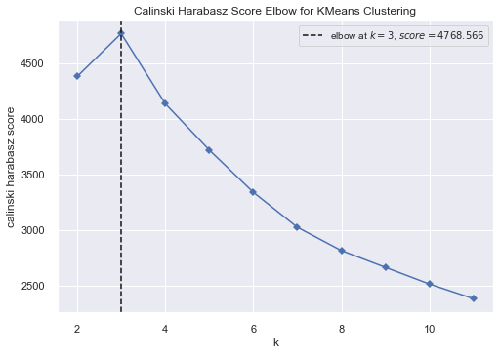

SOM + K-Means Distortion Elbow Plot

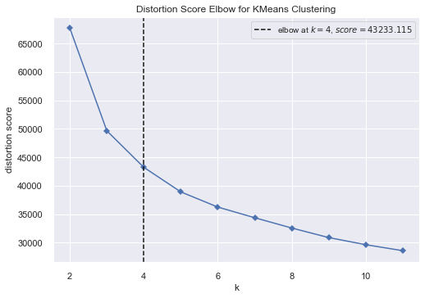

Component Planes for the SOM + K-Means Clustering

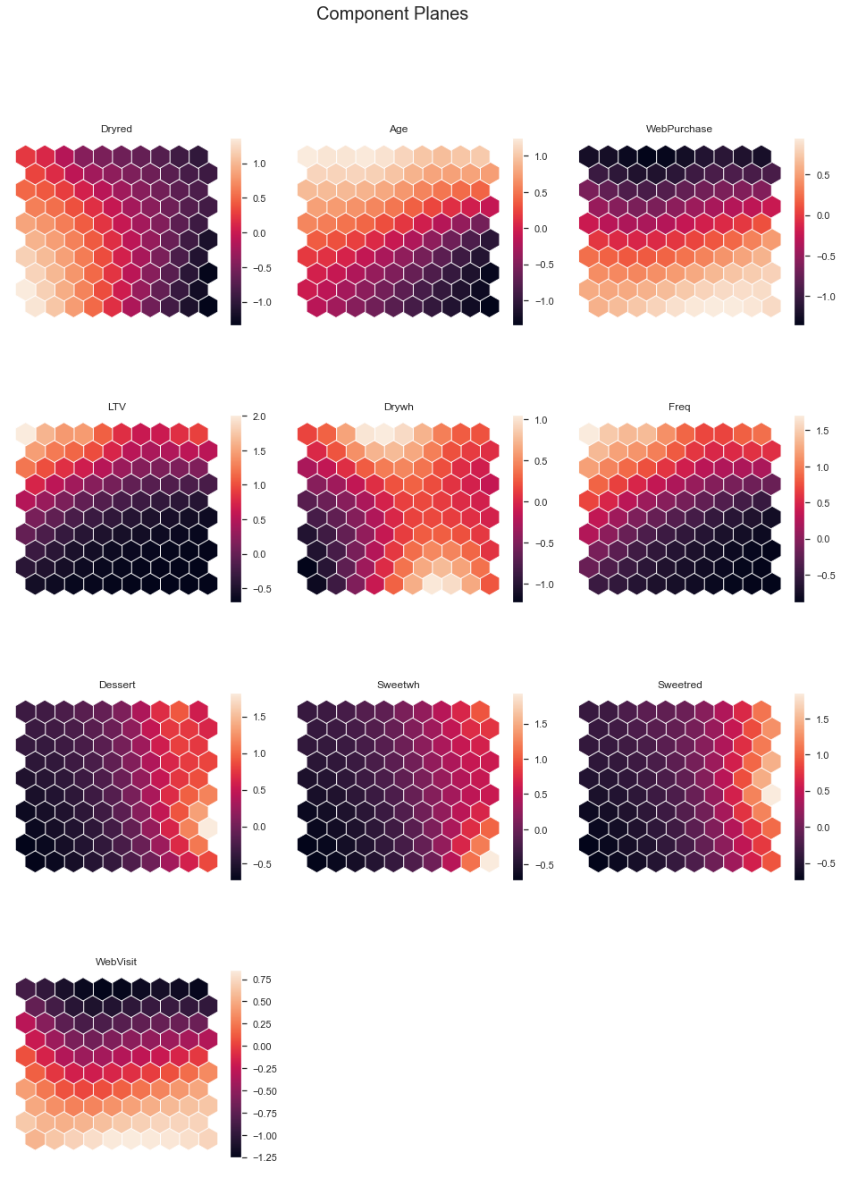

Cluster Simple Profiling K-means

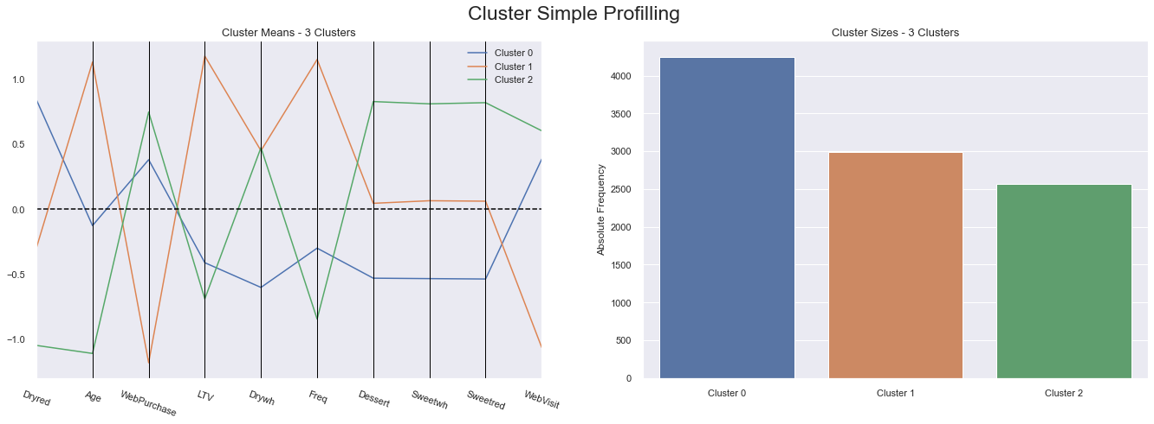

Mini Batch K-Means Distortion Elbow Plot

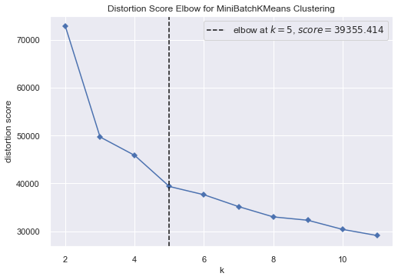

Mini Batch K-Means Calinski-Harabasz Elbow Plot

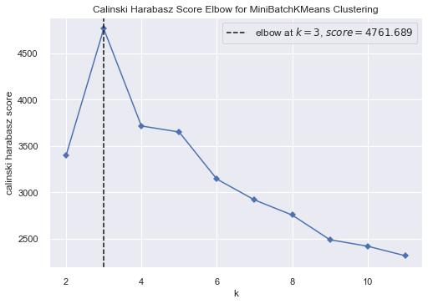

Cluster Simple Profiling Mini Batch K-means

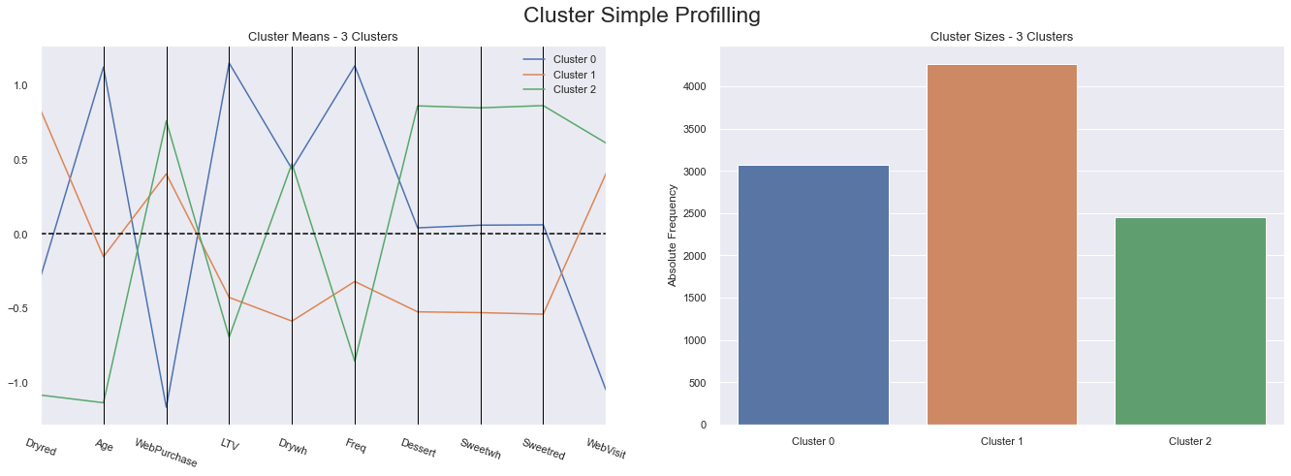

Cluster Simple Profiling for Gaussian Mixture Model (GMM)

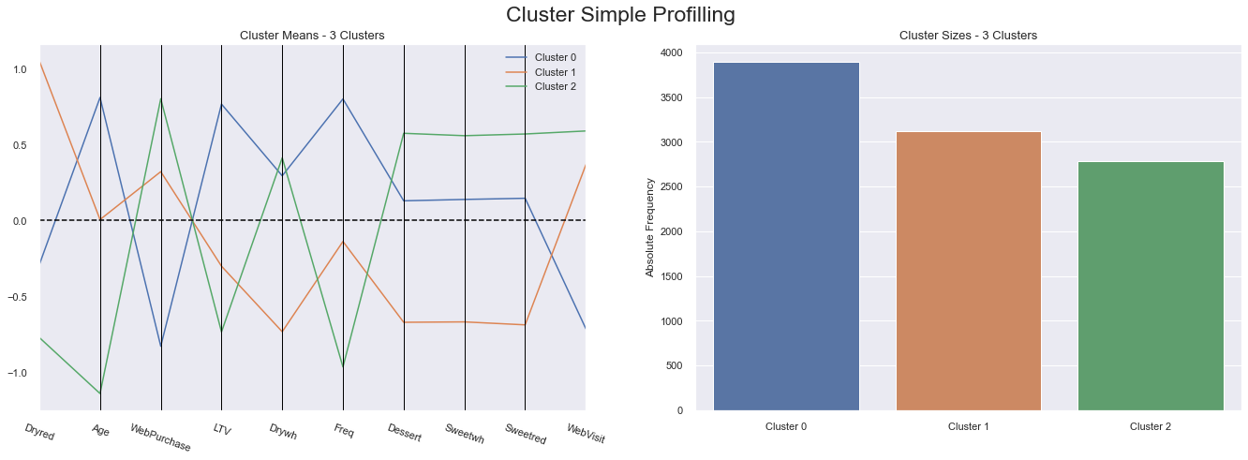

Average Sillhouete Plot for GMM

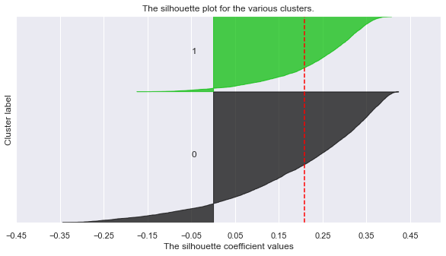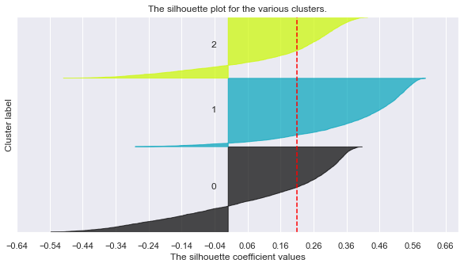 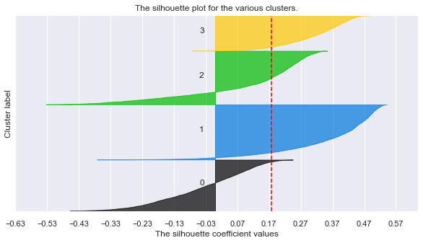 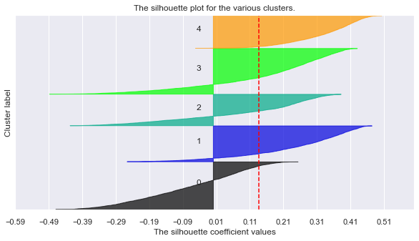

R2 plot for Hierarchical Methods (SOM + HC)

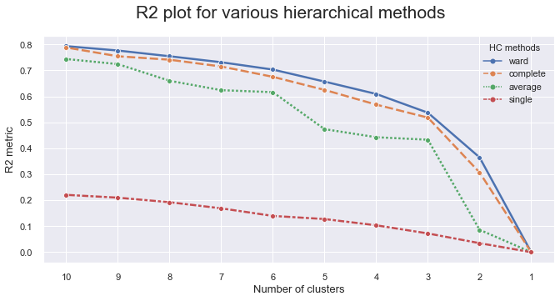

Hierarchical Clustering Dendrogram (SOM + HC)

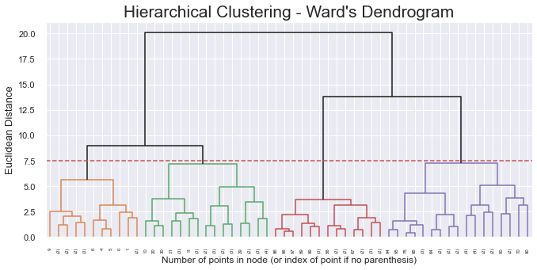

Cluster Simple Profiling for SOM + HC

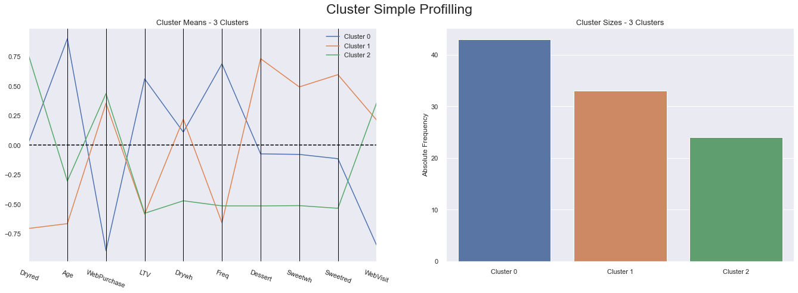

R2 plot for Hierarchical Methods HC

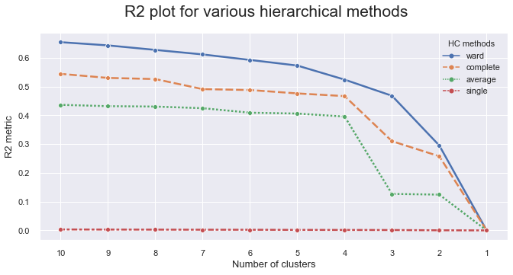

Hierarchical Clustering Dendrogram HC



Cluster Simple Profiling for HC

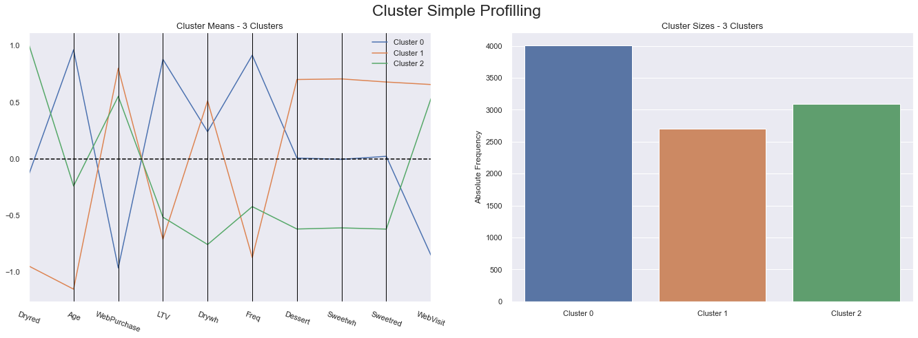

t-SNE Visualization for SOM+K-means Clustering

